**Bachelor of Engineering (Honours) in Software and Electronic Engineering**

**GMIT Department of Electrical and Electronic Engineering**

**Year 1**

**Industrial Automation**

**Gabriel Farragher 2022**

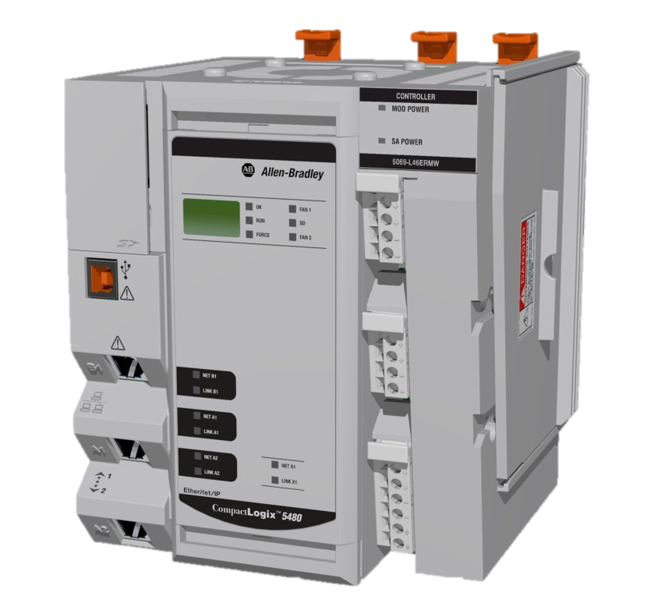

# Student Details:

* Date: January – April 2022
* Module: Industrial Automation
* Student Name:
* Student Number:
* Lecturer: Gabriel Farragher
* Document: Lab Reports

# Table of Contents:

1 Student Details: 2

2 Table of Contents: 3

3 Table of Figures: 3

4 GX Works 2– Lab 4 Exercise 1 – FB Two Way SW: 5

4.1 Introduction to Function Blocks: 5

4.1.1 Step 1: 6

4.1.2 Step 2: 7

4.1.3 Step 3: 9

4.1.4 Step 4: 10

4.1.5 Step 5: 12

4.1.6 Step 6: 13

# Table of Figures:

No table of figures entries found.

**Notes:**

|  |
| --- |
|  |
|  |
|  |
|  |
|  |
|  |
|  |
|  |
|  |
|  |
|  |
|  |
|  |
|  |
|  |
|  |
|  |
|  |
|  |
|  |

# GX Works 2– Lab 4 Exercise 1 – FB Two Way SW:

**Lab Overview:**

* In a previous exercise (Exercise 1) a Two-Way Switch was used in a School, connected as Inputs to a PLC and controlling the Stairs Light.
* The school has a requirement for many more of these Two-Way Switching configurations.
* To keep the PLC program lean, Function Blocks FB will be created.

## Introduction to Function Blocks:

* FB is an abbreviation for a Function Block that is designed to convert a ladder block, which is used repeatedly in a sequence program, into a component (FB) to be utilized in a sequence program.
* This not only increases the efficiency of program development but also reduces programming mistakes to improve program quality.
* **In this Lab add one FB for the Stairs Two-Way SW and another for the Hall Two-Way SW.**
* **Develop the Ladder Logic for this operation.**
* **Include Comments.**

**PLC I/O Addresses:**

* **iHallway_SW1 X1**
* **iHallway_SW2 X2**
* **oHallway_Light Y1**
* **iStairs_SW1 X3**
* **iStairs_SW2 X4**
* **oStairs_Light Y2**

**[Note: Save PLC software file as: GX W2 L4 Ex 1 GF B]**

### Step 1:

* Open GX Works 2
* Setup new project. [FXCPU, FX3G, Structured Project, Structured Ladder/FBD]
* Left click on **FB/FUN**

### Step 2:

* Right click and Add new.
* Enter **fb_2_Way_SW** as Data Name.
* Within the FB/FUN program create the following code:

* **Note the bSW1 ‘Class’ is changed to VAR_INPUT**
* **Note the bSW2 ‘Class’ is changed to VAR_INPUT**

* **Note the bLight ‘Class’ is changed to VAR_OUTPUT**

### Step 3:

* Check does your ‘**Local Label**’ within the **FB/FUN** match the following:

* Rebuild [Compile your code]:

* **It is blue?**

### Step 4:

* Now return to your **POU_01** Program.

* Left click on the **fb_2_Way_SW** you have just created and drag into **POU_01** program.

* Rename to **Hallway_Control**.

### Step 5:

* Go to **Global Label** and Open **Global1**.
* Enter the following:

### Step 6:

* Return to the **POU_01** program and enter the following:

* Rebuild [Compile] and ensure no error.
* Run program to test.

